Surgical Complications Report – Shelter Surgeries

Contents
Overview 2
Purpose and Scope 2
Purpose 2
Rationale 2
Scope 2
Operational Areas Encompassed 2
Definitions 3
Methodology 5
Decisions 5
Stratification 5
Timeframe 5
Complexities 5
Numerator 6
Denominator 6
Data Visualization 6
Technical Implementation 9
Source Data Updates 9
Current Code Repository 10
Report Generation Logic 10
Data Outputs 11
Excel-based Reporting File 11
Online Summary Dashboard 11
Automation and Operations 11
Scheduled Execution 11
Report Change Log 11

Overview

Purpose and Scope

Purpose
To monitor surgical and anesthetic complications in the shelter, using the most frequently performed surgeries as a barometer.

Rationale
Shelters clinics perform large numbers of elective surgical procedures. It is essential to ensure that complication rates are as low as possible and to rapidly remediate any problems. Complications reports can also showcase the safety of high-qulaity-high-volume spay/neuter.

Scope
The report summarizes minor and major surgical complications, as well as anesthetic complications and deaths. Spay, neuter and dental surgeries are included. Surgical complications are stratified by procedure type and by surgeon. There are different reports for public surgeries and shelter surgeries, because different teams are involved and the underlying record-keeping software is different. However the outputs of the reports are similar.

Operational Areas Encompassed
- Surgical proficiency
- Sterility
- Anesthetic safety
- Postoperative recovery and care

Definitions
- The definitions are used by staff to enter complications in the Conditions list in the shelter software (PetPoint).
- Threshold: Problems are only entered if veterinary intervention is required day-of, if a subsequent veterinary examination is needed, or if a registered veterinary technician delegated to manage less serious complications considers that a condition entry and medical note are warranted.

 | Definition | Examples | Examples of what NOT to include
Surgical complication | - Complication directly related to the surgery  - Requires intervention beyond local minor wound management | - Infection requiring systemic antibiotics  - Suture reaction requiring surgical removal  - Large seroma  - Severe bruising  - Surgical repair or revision  - Hemoabdomen | - Hypothermia  Drug overdose or reaction  - Pain (enter condition)  - Anorexia, vomiting, diarrhea (enter condition or adverse drug reaction if suspected)
Incision complication | Minor incision complication requiring only topical treatment | - Minor infection  - Small seroma  - Tattoo incision needs re-gluing  - Small suture tag that just requires snipping | Clipper burn - this is not directly related to the surgery itself
Dehiscence, dental | Dental incision open to the extent that repeat surgery is needed or being considered |  | Very small area involved, no recheck required, surgery not considered
Ranula | Ranula (significant swelling) formed at site of lower premolar extractions |  | Mild swelling in this area
Anesthetic arrest | - Cardiopulmonary arrest during or soon after anesthesia or sedation i.e. no pulse or no respiration  - Do not enter transient apnea (a few seconds, minimal or no intervention needed)  - Enter apnea if it requires specific support beyond a few seconds |  | CPA unrelated to anesthesia or sedation - enter as "Arrest "
Anesthetic complication | - Complication directly related to anesthetic drugs or sedative drugs  - Complication directly related to the state of being heavily sedated or anesthetized | - Delayed recovery markedly beyond what is expected  Aspiration during anesthesia  Hypothermia  - Record as a complication if temp < 35 OR temp < 37.2 and not sufficiently improved after 30 minutes of warming  Thermal burn  Adverse event directly related to anesthetic or sedative drugs  - Post-intubation tracheal irritation | - Complication related to other medications used, e.g. meloxicam overdose or anaphylactic reaction to an antibiotic  - Adverse event relating to local anesthetic (e.g. cardiac complications from lidocaine)

Methodology

Decisions

Population Scope | - Chose dogs, cats and rabbits because it is important to track complications and outcomes for all species routinely undergoing surgery.  - Routine, frequent surgeries only.
Stratification | - Stratified by surgery type.  - Stratified by surgeons.  - Anesthetic complications/arrest not stratified.
Inclusion/Exclusion | - Included routine spay, neuter, and dental surgeries performed within the shelter program.  - Included complications directly attributable to the surgical or anesthetic event.  - Report does not include multiple simultaneous procedures so dentals are most likely under-represented

Stratification
- Species – dogs, cats, rabbits
- Surgery type – spay, neuter and dental
- Minor and major complications
- Anesthetic complications
- By surgeon

Timeframe
The report runs monthly. Data can be viewed by month, year-to-date or previous year + year-to-date.

Complexities
- Dental revisions (e.g. dehiscence) were also entered as dental procedures and difficult to associate with the original surgeon.
- Spays or neuters are often performed on the same day as a dental surgery. Decisions were made about how to identify surgeries and whether to include all of them or only the dental (less common surgery than spay/neuter).
- Occasionally the same surgery was entered twice. The code removed any repeat surgeries if there were two identical surgeries entered for the same day.
- There were occasional administrative errors (e.g. the person logged in showed as the surgeon). These were adjusted manually where they were noticed.

Numerator

Numerator 1: Surgical and Incision Complications
Includes:
- Surgical complication
- Incision complication
- Dehiscence, dental
- Ranula

Numerator 2: Anesthetic Complications
Includes:
- Anesthetic arrest
- Anesthetic complication

Denominator

Denominator 1: Surgical and Incision Complications (SIC)
- All stand-alone spay surgeries during the period of interest (i.e. not performed on the same day as another surgery)
- All stand-alone neuter surgeries during the period of interest (i.e. not performed on the same day as another surgery)
- All stand-alone dental surgeries during the period of interest (i.e. not performed on the same day as another surgery)

Denominator 2: Anesthetic Complications
All stand-alone surgeries of interest (spay, neuter and dental) during the period of interest.

Data Visualization

This section provides selected screenshots of reports as they currently appear, to illustrate the output.

This example shows spay surgery complications for a period in 2025.

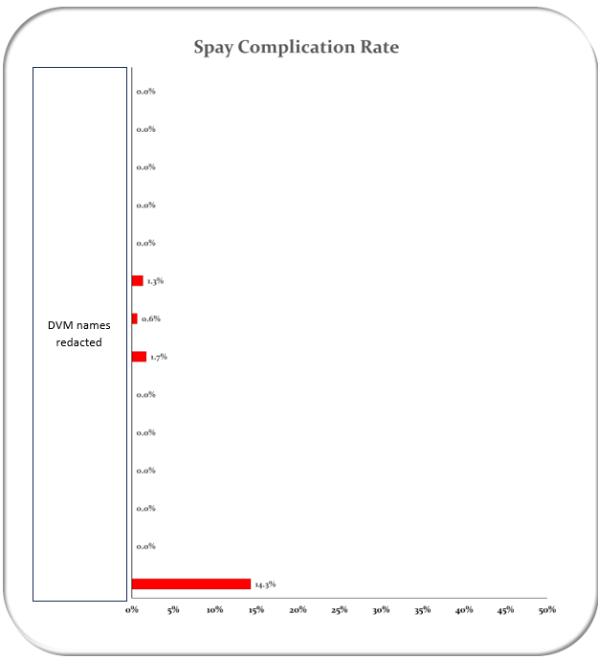

This result would prompt an investigation for the surgeon ("DVM B”) with a complication rate of 14.3%.

The table provided as part of the report gives critical context by providing denominators. In this example, DVM B performed 7 surgeries, and had 1 complication (14.3%). Compare this with DVM A, who performed 156 surgeries and also had 1 complication (0.6%).

Surgeon | Comp | NoComp | Total | % Comp
DVM | 0 | 46 | 46 | 0.0%
DVM | 0 | 1 | 1 | 0.0%
DVM | 0 | 8 | 8 | 0.0%
DVM | 0 | 3 | 3 | 0.0%
DVM | 0 | 1 | 1 | 0.0%
DVM | 1 | 75 | 76 | 1.3%
DVM A | 1 | 156 | 157 | 0.6%
DVM | 2 | 114 | 116 | 1.7%
DVM | 0 | 1 | 1 | 0.0%
DVM | 0 | 2 | 2 | 0.0%
DVM | 0 | 11 | 11 | 0.0%
DVM | 0 | 6 | 6 | 0.0%
DVM | 0 | 1 | 1 | 0.0%
DVM B | 1 | 6 | 7 | 14.3%
Grand Total | 5 | 431 | 436 | 1.1%

Knowing that DVM B only performed a small number of surgeries because they were still in training, it might still be necessary to review this complication. By double-clicking in the complication column for that surgeon, the animal’s details are returned in a new tab. The medical record can be directly reviewed. In this case, it was a minor incision complication. No further action was needed.

ID | Species | SurgeryType | SurgeonName | Type | SurgeryMonth
Redacted | Cat | Ovariohysterectomy | DVM B | Comp | 2025-08

The image below shows a simplified report, presented in the PowerBI Dashboard for high-level “at a glance” monitoring.
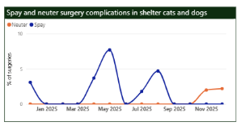

Quality Control

During development of the report, it is important to verify that outputs are valid. Errors may originate in the data itself (e.g. entry errors, such as associating an RVT with the surgery instead of the DVM) or in data processing (associating a corrective surgery with the complication instead of the original surgeon). Manual reports are compared for errors with the coded report to identify any systemic issues. The quality control is dependent on adequate documentation of the logic of the report generation process.

Technical Implementation

The execution script combines Python user-defined functions and SQL queries to extract the report files from a SQL server. By leveraging the capabilities of both Python and SQL, the script facilitates the retrieval and processing of the required data for generating the report files.

Source Data Updates
Source data are received from PetPoint on a recurring monthly basis via an automated file transfer process. The reporting process is designed to run after the monthly data file is received.

Current Code Repository
The current technical implementation for this report is available in GitHub:
THS-Metrics/metric-reports.

Report Generation Logic

Necessary information in the database is pulled into a data sheet using SQL server. Data is stored in tables where animal's records can be associated using unique numbers to create a data sheet with all necessary information associated with that animal in a single downloadable excel sheet. Note that it is important to check that these table connections are associating information correctly.

The Numerator sheet reflects surgery complications extracted using complication categories created in the conditions field in PetPoint. The denominator reflects all surgeries completed as is pulled from the procedure table. Where multiple identical surgeries are entered for the same individual, the sheet is cleaned of repeats and the initial entry retained.

Surgery complications are associated with the surgeries using the logic that the most recent previous surgery is likely the surgery associated with the complication.
Python is used to generate a consolidated data sheet from these three sheets. The output is written to an Excel file, which serves as the primary output of the data processing step and as the interface between the automated data extraction and the downstream reporting. Within this Excel file, the denominator data are saved to one worksheet, and the numerator data are derived from the consolidated data sheet and saved to a separate worksheet. Storing both components in the same Excel file allows the data to be reviewed, reused, and linked directly to reporting tools.

Data Outputs

Excel-based Reporting File
The report’s Excel-based reporting file has been predesigned with tables and visualizations, with the data source being the output Excel file generated by the python script. generated by the Python script. Whenever the script is executed, the reporting file refreshes automatically, ensuring that it remains updated with changes in the underlying data.

Online Summary Dashboard
An online summary dashboard presents a simplified view of selected metrics derived from the same underlying data. The dashboard uses PowerBI. It is intended for high-level monitoring “at a glance” and does not expose the full underlying dataset available in the Excel-based reporting file. It is available to all staff in our organization.

Automation and Operations

Scheduled Execution
The reporting process is designed to be run automatically on a scheduled basis. Automation consists of executing the Python reporting script at a defined interval in an environment where required dependencies and credentials are available.

For this report, automation is intended to run once per month. Each execution refreshes the processed output files, which in turn update any downstream reporting or summary views that depend on them. Successful execution can be verified by confirming that output files have been updated for the current reporting period.

Automation may be implemented using any scheduling system capable of running a Python script (e.g. task schedulers, cron jobs, or workflow tools), provided the script is executed in a configured Python environment.

Report Change Log
MMDDYY | Change | Initials

